Remember, you’re still studying for STEP even though you have to pass their exams. Keep annotating, keep learning. Stay 6 ft apart
*Repro is giant, so I’m mixing it into the endocrine week because it’s smaller*
-Illegitimi non carborundum-
START DOING PUBLIC HEALTH/ BIOSTATS ANKI NOW (easy points)--> you’re only gonna have time to spend one weekend on it, so do the anki now.(in drive)
 | Monday | Tuesday | Wednesday | thursday | friday | saturday | sunday
Week 5 TOPICS | GGOER
Videos (5 per day) | B&B GI: 1.1 embryo , 1.2 anatomy, 1.3 blood supply, 1.4 G.I tract, 1.5 liver gallbladder pancreas | B&B GI: 1.6 salivary glands, 1.7 hernias, 2.1 bile, 2.2 bilirubin, 2.3 GI secretions | B&B GI: 2.4 GI hormones, 2.5 exocrine panc, 3.1 esophageal disorders, 3.2 liver disease, 3.3 cirrosis | B&B GI: 3.4 liver tumors , 3.5 wilsons & hemochromatosis, 3.6 gallstones, 3.7 biliary disorders, 3.8 gastric disorders | B&B GI:3.9 malabsorption, 3.10 acute panc, 3.11chronic panc & cancer, 3.12 intestinal disorders,  Sketchy path: Panc cancer | B&B GI:3.13 IBD, 3.14 colon cancer, 3.15 carcinoid,  Sketchy path: Ulcerative colitis & crohns | 40 block uworld  & REST
FA pages (8) | 358-365 | 367-373 | 374-381 | 382-389 | 390-397 | 398-401
FTM review | FA: p. 34  B&B: DNA structure  FA p. 35 | FA p. 36  Pixorize: de-novo purine, de-novo pyrimidine | FA p. 37  Pixorize: purine salvage | FA p. 38  B&B: DNA replication | FA p. 39  B&B: DNA mutations  Pixorize: xeroderma pigmentosum | FA p. 40  B&B: repair  Pixorize: ataxiatelangiectasia, bloom syndrome
Sketchy Review | -histoplasmosis  -blastomycosis  -VZV  -antiemetics  -heparin | -coccidiomycosis  -paracoccidioides  -HHV-6 roseola  -H2 receptor blockers  -warfarin | -malesia furfur  - dermatophytes  -HHV-8 kaposi  -laxatives  -antiplatelet | -sporothrix  -candida albicans  -polyoma virus  -NSAIDS  -thrombolytics | -aspergillus  -cryptococcus  -papilloma virus  -Gout drugs  -indirect sympathomimetics | -mucormycosis  -PCP pneumonia  -parvovirus  -statins
Questions | 20 Rx GI | 20 Rx GI | 20 Rx GI | 20 Rx Gi | 20 x Gi | 20 Rx Gi
Week 6 TOPICS | Endocrine |  |  |  |  | Review Biostats today, | PLEASE
videos. | B&B endo: Thyroid 1-3  Sketchy path: Thyroid CA  B&B Repro: 1.1 embryogenesis, 1.2 embryonic genes | B&B Endo: Adrenals 1-3  B&B Repro: 1.3 germ layers, 1.4 errors in morphogenesis | B&B Endo: Pancreas 1-2  Sketchy pharm: Insulin, diabetes pharm  B&B Repro: 1.5 teratogens, 1.7 cleft lip | B&B Endo:Repro hormones 1-4  Sketchy path: reproductive hormones  B&B repro: 1.6 teratogens II, 1.9 pharyngeal pouches & clefts | B&B Endo: Pituitary 1-4  Sketchy path: men syndrome  B&B Reptro: pharyngeal arches  *Can skip men syndrome B&B if you watch the sketchy | https://www.youtube.com/watch?v=75pQPB1RF50  https://www.youtube.com/watch?v=VMI9UuNqoGI  Biostats Anki if you don't have it | PUBLIC HEALTH
FA pages | 326-331 | 332-336 | 337-342 | 343-347 | 347-355 | PUBLIC HEALTH 256-267 | 268-274
FTM review | FA p. 41  B&B: transcription | FA p. 42  FA p. 43  B&B: translation | FA p. 44  FA p. 45  Pixorize: zellweger, refsum, adrenoleukodystrophy | A p. 46  B&B: cell cycle | FA p. 47  Pixarize:: Icell, COP1 &COP2
Sketchy review | -giardia  -E.histolytica-  Cryptosporidium  -propylthiouracil | -toxoplasmosis  -trypanosoma brucei  -Naegleria fowleri  - | -trypanosoma cruzi  -babesia  -plasmodium | --leishmaniasis  -trichomoniasis  -intestinal nematodes | -tissue nematodes  -cestodes  -trematodes | Review biostats/public health
Questions | 20 endocrine Rx | 20 endocrine Rx | 20 endocrine Rx | 20 endocrine Rx | 20 endocrine Rx
Week 7 TOPICS | Rheumatology, immunodeficiencies, vasculitis, hypersensitivity
Videos | B&B immuno: Innate immunity, T-cells, B-cells, the complement system  Sketchy path: complement system disorders | B&B immuno:Lymph Nodes & spleen, hypersensitive (high yield), transplant rejection (high yield)  Sketchy path: phagocytic cell disorders | B&B immuno:Immune deficiency syndromes,immunosuppressive drugs, rheumatoid arthritis,  B&B MSK: osteoarthritis  Sketchy path: osteoarthritis, rheumatoid arthritis | B&B immuno: SLE, scleroderma, srjogensm  B&B MSK:  SKetchy path: SLE, srojens, polymyositis | B&B immuno: vasculitis (in cardio section of FA)  Pixorize: buerger's vasculitis  Sketchy path: large & medium vasculitis | Review all MSK FA Path pages | UWORLD 40 block  & REST
First aid pages biochem review | FA p. 48  B&B: cell structure | FA p. 49  B&B: cytoskeleton  Pixorize: kartagener's | FA. p. 50  B&B: connective tissue  Pixorize: collagen synthesis | FA p. 51  Pixorize: Osteogenesis imperfecta, ehlers danlos, menkes | FA p. 52  Pixorize: marfans  B&B: PCR | FA p. 53  B&B: blotting | FA p.54  B&B: flow cytometry, ELISA
FA pages
Review  Sketchy | Antifungals (amphotericin, azoles, griseofulvin)  staph aureus, staph epidermidis, strep pyogenes, strep agalactiae | HIV drugs (all)  Strep pneumo, enterococcus, bacillus anthracis, tetanus | Glucocorticoids, NSAIDS  Botulism, c.diff, c.perfringes, c.dip | Antiviral hepatitis (interferon, ribavirin)  Listeria, actinomyces, nocardia, klebsiella | Acyclovir, ganciclovir  Neisseria overview, neisseria meningitidis, neisseria gonorrhoeae,proteus | Methotrexate, salmonella, shigella, e.coli, yersinia
Questions | Weekdays: UWORLD 20 random, Rx 20 on /immuno everyday  WEEKENDS: do 40 UWORLD minimum  Sketchy path immuno link: https://drive.google.com/drive/folders/1YjEl2b-yc4x8wPJbdHIcufGuxUZsCevd |  |  |  |  |  | 40 UWORLD
Week 8 TOPICS | Repro (tough week, do your best)
videos | B&B repro: 1.10 genital embryo, 2.1-2.5  Sketchy path: reproductive hormones | B&B repro: 2.6 HTN in preg, 2.7 placental comp, 2.8 gestational tumors, 3.1 vag CA, 3.2 Cervical CA  Sketchy path: hydatidiform moles, vulvar & vaginal lesions, cervical CA | B&B repro:  Sketchy path: polyhydramnios, gestational disorders | B&B repro:  Sketchy path: structural causes of abnormal uterine bleeding | B&B repro:  Sketchy path: Both ovarian videos, and both breast videos | EXAM????
First aid pages | FA: 598-604  +641-643 | FA:605-611  +641-643 | FA:612-618  +641-643 | FA: 619-625  +641-643 | FA:626-632  +641-643
FTM review
(+annotate)
Sketchy Review | None, repro is too big
questions | Weekdays: UWORLD 20 random, Rx 20 on repro everyday
*FA pages correlate to 2019 version

The key to the first BSCE is to keep up with learning pathophysiology while simultaneously realizing most of what you’ll be tested on is FTM
IF YOU ARE WEAK ON FTM PLEASE FOCUS ON THAT FIRST AND MAKE IT YOUR PRIMARY FOCUS

Biggest regret of term 5: Not using sketchy path more, really, it’s time now. You’ve seen all the pharm and micro multiple times if you’ve been following my schedules. Now it’s time to up your game and add path.

Resources

-For FTM/biochem/genetics
Pixorize: if sketchy helps you at all, this brand does an amazing job at being sketchy for all of FTM. metabolic pathways,fatty acid synthesis, meissner's corpuscles, glycogen storage diseases, and they’re constantly adding new videos. This was a life saver for all the stuff I didn't properly learn 1st year. It’s also still pretty cheap.
https://pixorize.com/browse

-For Physiology/anatomy
Physeo: If Boards and beyond still isn’t cutting it for physiology and anatomy physeo is an excellent resource. It simplifies everything and gives a lot of practice questions as you go. Also relatively cheap (split it with a couple friends)
https://physeo.com/dashboard/

Boards & beyond
-please make sure to annotate well and you won't have to watch a single one during dedicated. Boards and beyond is a lot of work, and sometimes Jason will start going on tangents and you’ll think *this cannot be testable* and you zone out, guarantee the next day you get a question wrong on just that topic. EVERY WORD HE SAYS IS TESTABLE ON STEP. So write it all down in your first aid and you’ll be able to devote all of dedicated to questions.

Sketchy: Obviously.

GENERAL PRINCIPLES
- Biochemistry
- Immunology
- Microbiology
- General path
- General Pharmacology
- Public health sciences

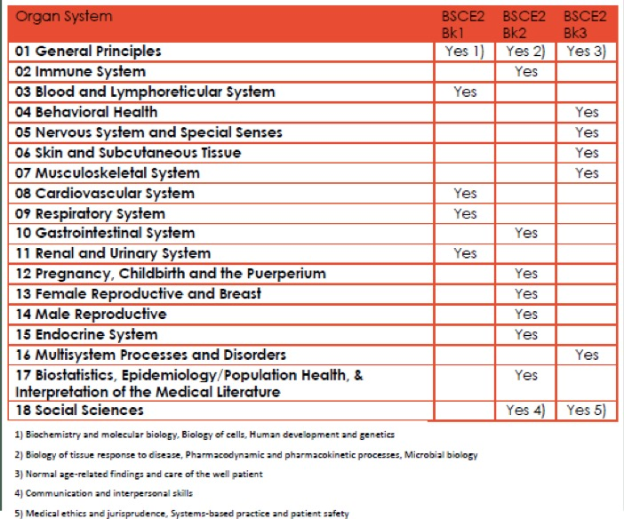

Reminder, there is a light at the end of the tunnel. I had a patient hold my hand this week, I got to hold a scalpel, I got to help decide which antibiotics to give a patient in the ICU. These things matter, I swear. Learn as much as you can.
